Alexander Yamoldin. Assignment 4

[https://www.wolframalpha.com/input?i2d=true&i=Runge-Kutta+method%5C%2844%29+Divide%5BdP%2Cdt%5D+%3D+%5C%2840%290.009*cos%5C%2840%29t%5C%2841%29%5C%2841%29P%5C%2840%291+-+P%5C%2841%29-1+from+1+to+20%5C%2844%29+P%5C%2840%290%5C%2841%29%3D100](https://www.wolframalpha.com/input?i2d=true&i=Runge-Kutta+method%5C%2844%29+Divide%5BdP%2Cdt%5D+%3D+%5C%2840%290.009*cos%5C%2840%29t%5C%2841%29%5C%2841%29P%5C%2840%291+-+P%5C%2841%29-1+from+1+to+20%5C%2844%29+P%5C%2840%290%5C%2841%29%3D100)

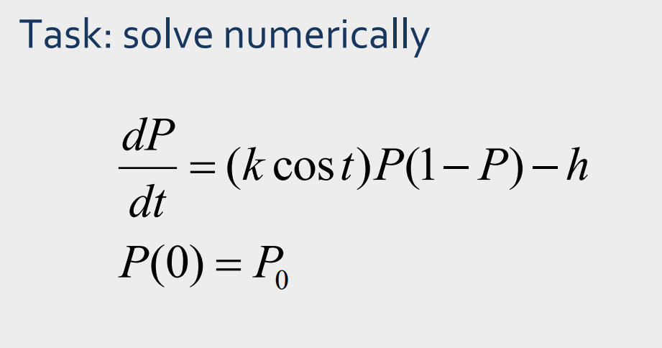

Where,

k – growth rate

t – time

P – population

h – constantly decreasing

P(0) – initial value

Take

k – 0.001

h – 0.5

P(0) – 100

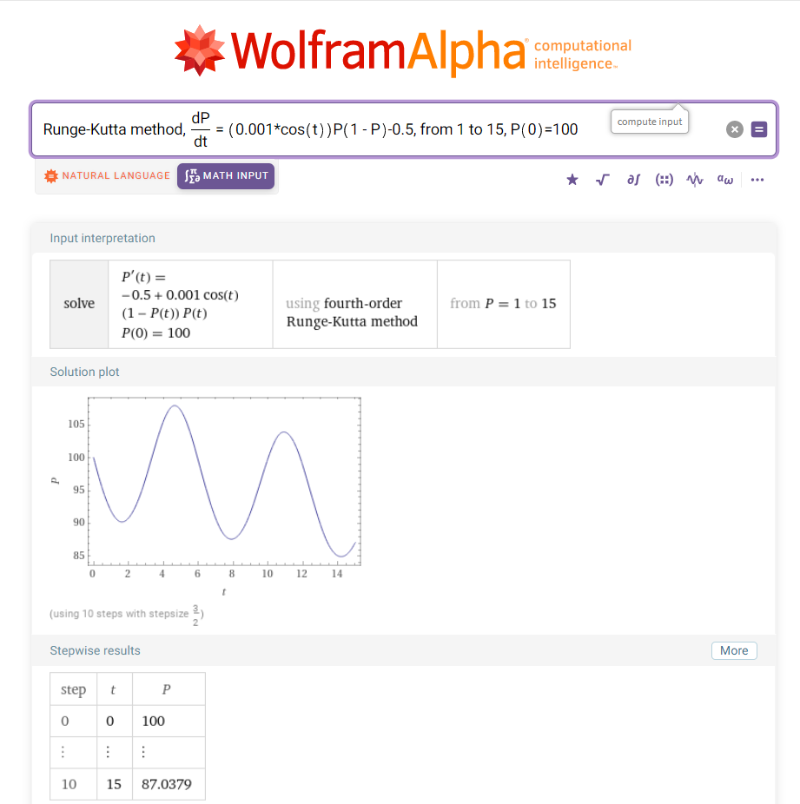

In this case we see wave behavior of population. But in total population decrease.

Take

k – 0.001

h – 0.02 (decrease more than 10 times)

P(0) – 100

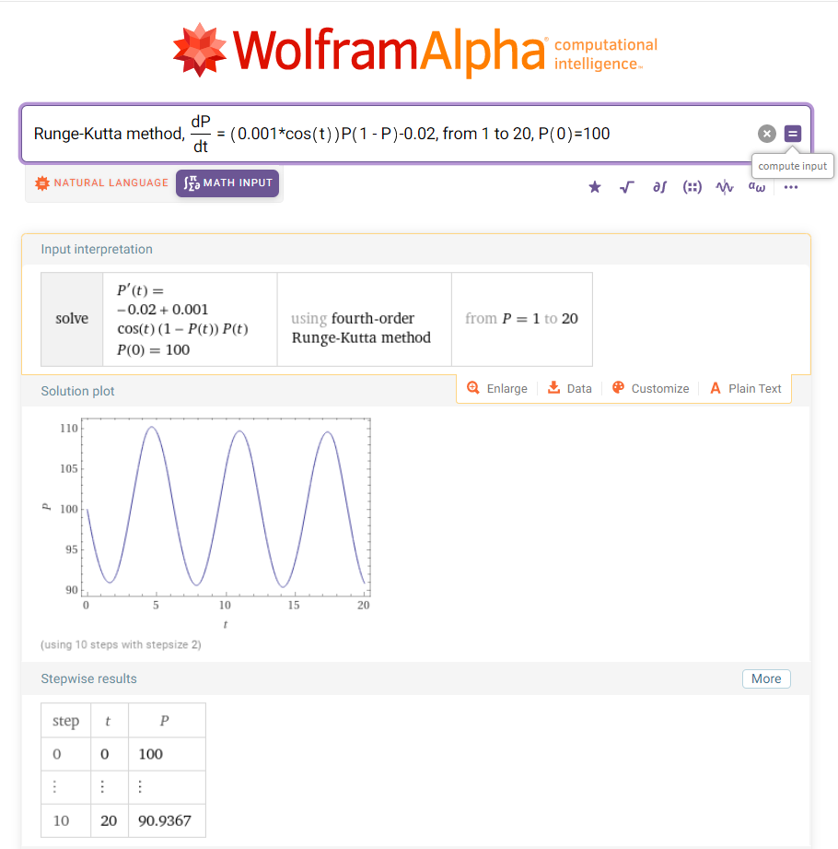

In this case we see stable sinusoid Population with period about 6 steps

Take

k – 0.009 (increase on 9 times)

h – 1 (decrease more than 50 times)

P(0) – 100

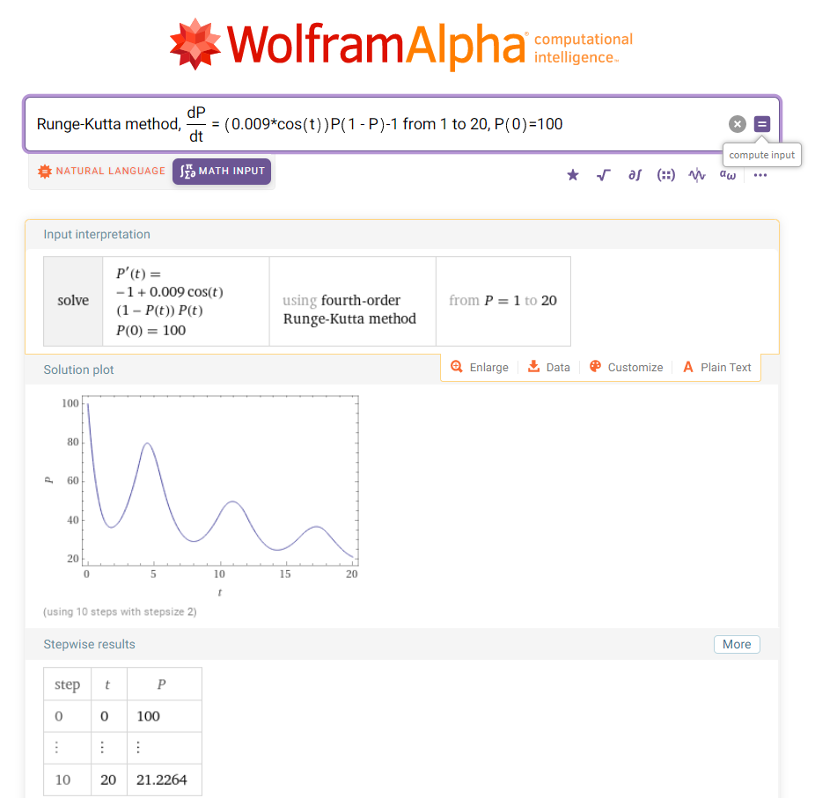

In this case we see that population stably decrease with a little grow periods.